**2.1 The Cell Cycle and Mitosis\***

* Autosomal cells (2n) undergo mitosis
* Germ-line cells (2n) undergo mitosis, OR meiosis to produce Sex cells i.e. gametes (n)

The Cell Cycle

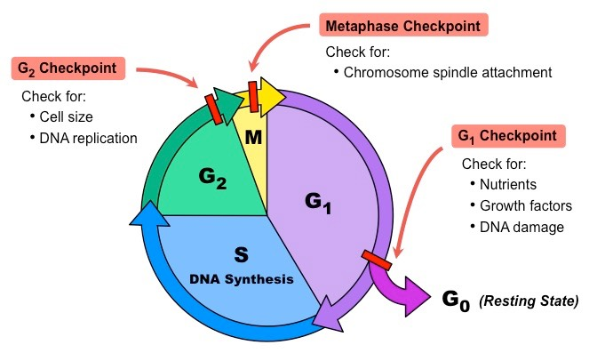

Control of the Cell Cycle

1. G1/S checkpoint: DNA damage
   1. p53 protein repairs DNA
2. G2/M checkpoint: Cell size and DNA replication
   1. Cyclins bind to cyclin-dependent kinases (CDKs) → cyclin concentrations vary → create CDK-cyclin complex → phosphorylate transcription factors → promote transcription of genes required for the next stage of cell cycle
3. Metaphase checkpoint: Chromosome spindle attachment → prevents non-disjunction
   1. Mad2 protein

Mitosis

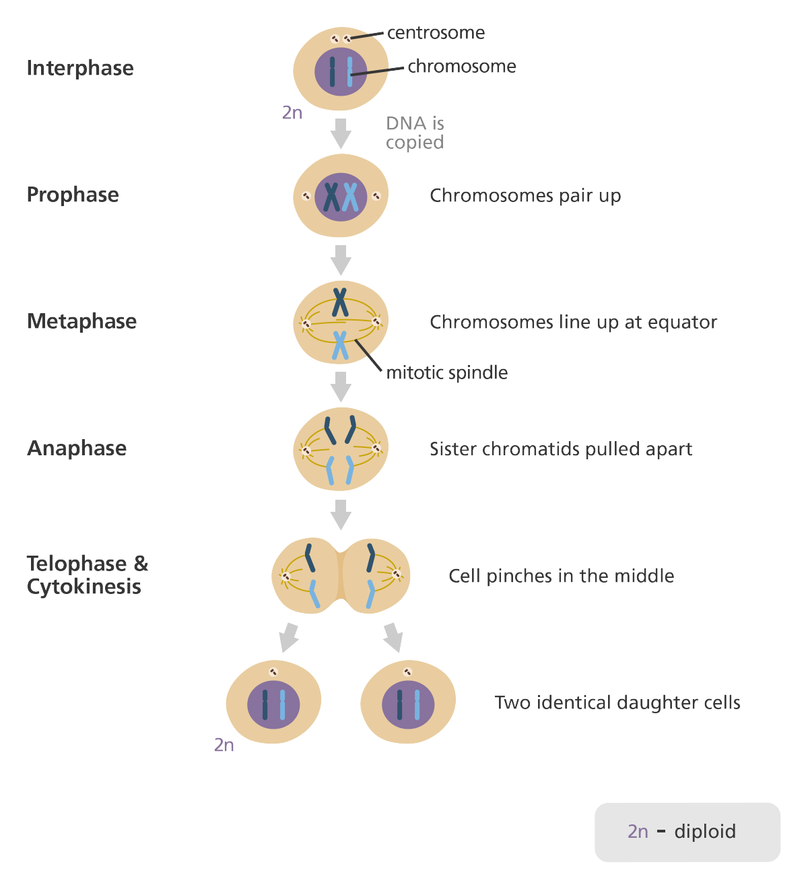

**2.2 Meiosis\***

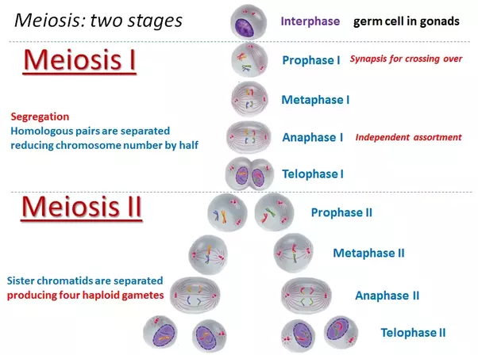

Genetic Variation

1. Random fertilization
2. Crossing over of non-sister chromatids of homologous chromosomes at **Prophase I**
3. Independent assortment of homologous chromosomes at **Metaphase I**
   1. possible combinations, where n = number of pairs

**2.3 The Reproductive System\***

* Y chromosome has a sex-determining region Y (SRY), which codes for a transcription factor that initiates testis differentiation → forms male gonads

Male Reproductive Anatomy

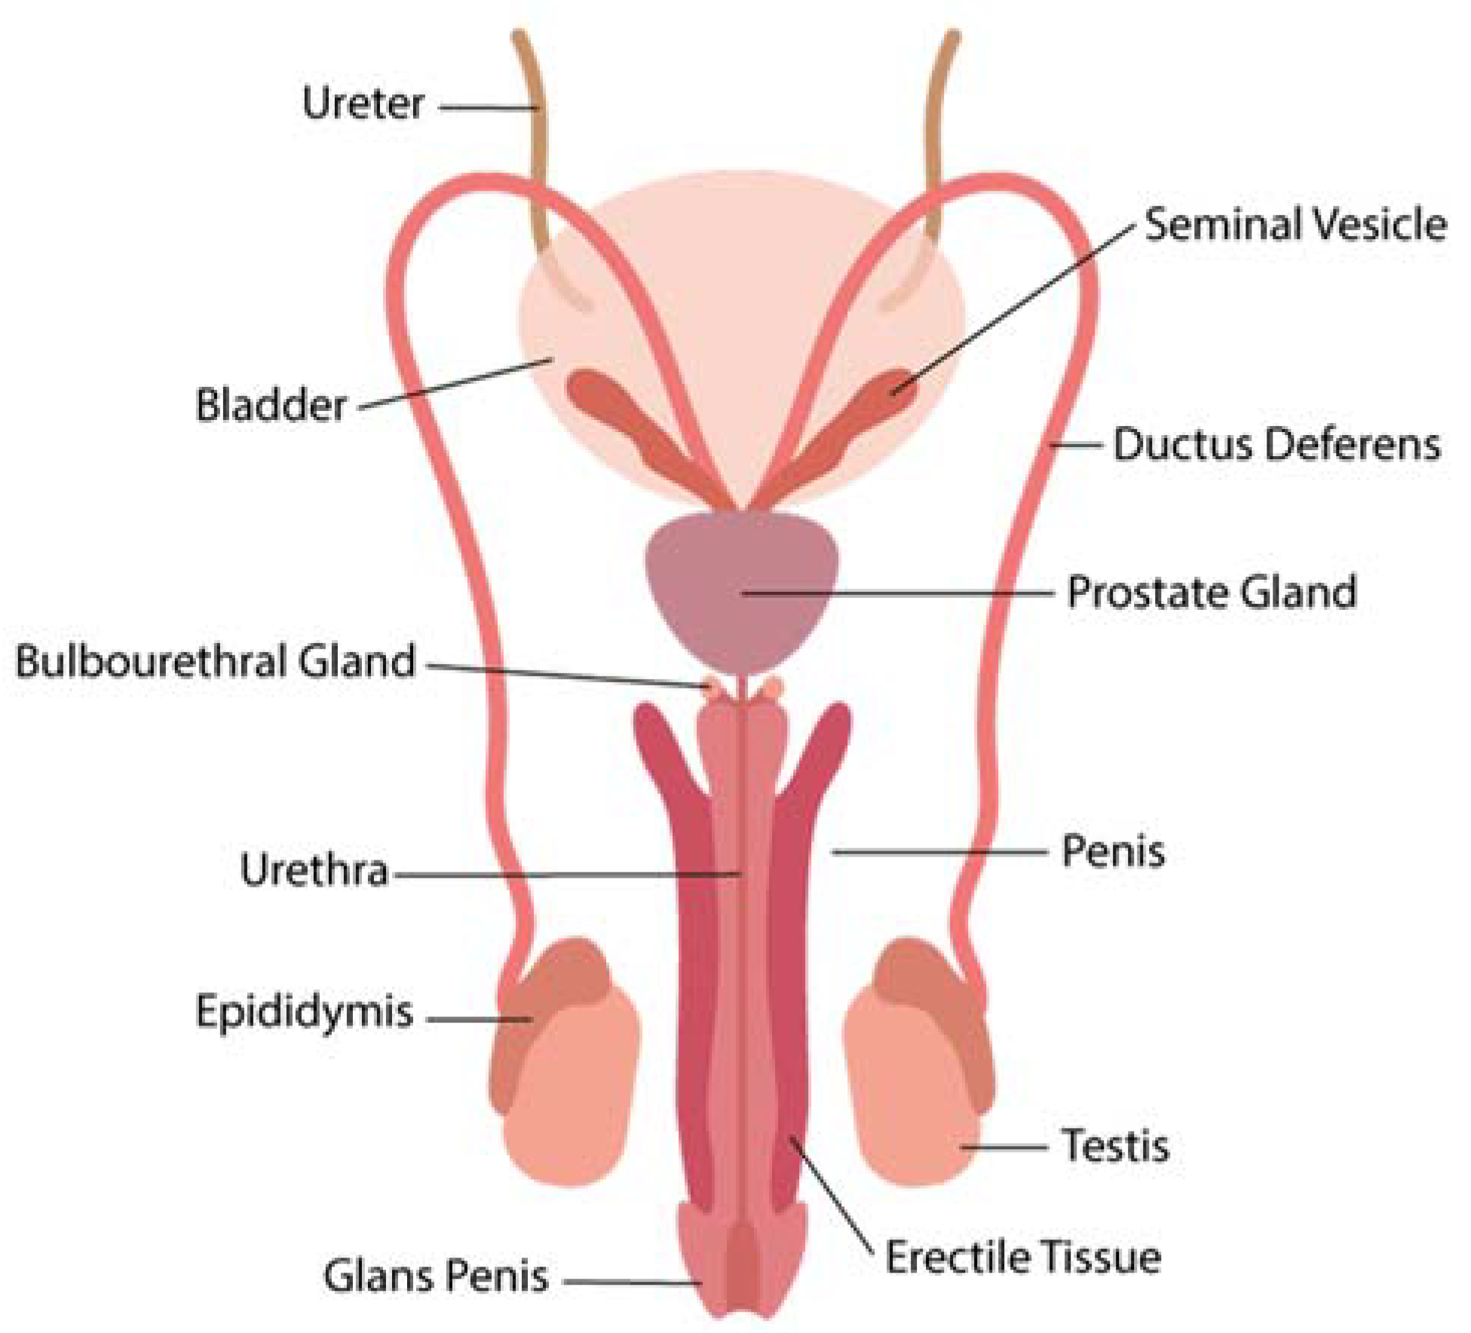

1. Testes
   1. Seminiferous tubules: sperm are produced here, where they are nourished by **Sertoli cells**
   2. Interstitial cells (of Leydig): secrete **testosterone** andother **androgens**
2. Scrotum (contains testes)
   1. Hangs below penis and maintains 2 to 4°C below body temperature
   2. There is a layer of muscle around the **vas deferens** that can raise and lower the testis to regulate the temperature
3. Epididymis
   1. Sperm flagella **gain motility** here and are **stored** until ejaculation
4. Vas deferens
5. Ejaculatory duct
6. Urethra

Seminal fluid (+ sperm = semen)

* **Seminal vesicles** contribute **fructose** to nourish sperm
* Both the seminal vesicles and **prostate gland** give mid **alkaline** properties → sperm is able to survive in the relative acidity of the female reproductive tract
* **Bulbourethral (Cowper’s) glands** produce a clear viscous fluid → **cleans** out any remnants of urine + **lubricates** the urethra during sexual arousal

Spermatogenesis

* Spermatogonia (diploid stem cells) → diploid primary spermatocytes (after S stage) → haploid secondary spermatocytes (after Meiosis I) → haploid spermatids (after Meiosis II) → mature spermatozoa

Sperm

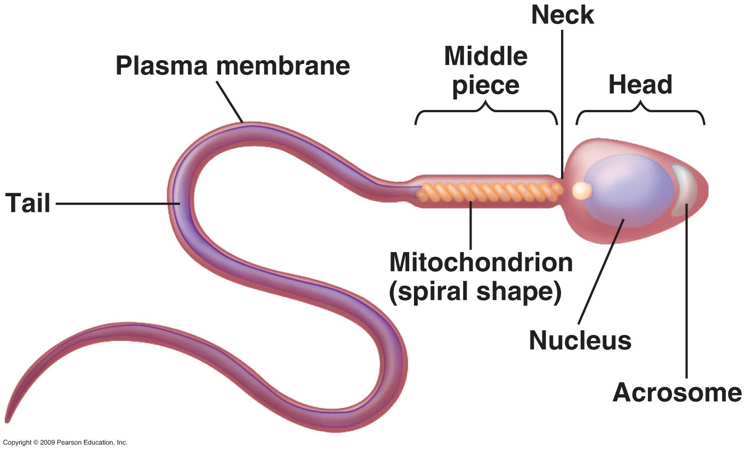

1. Head (contains genetic material)
   1. Acrosome (cap) derived from Golgi apparatus → contains **acrosomal enzymes** to penetrate ovum
2. Midpiece
   1. Contains mitochondria → generates **ATP** from fructose → energy to swim
3. Flagellum (for **motility**)

Female Reproductive Anatomy

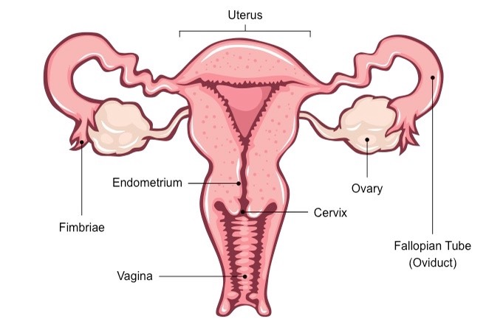

1. Ovary
   1. Consists of thousands of **follicles**, which contain, nourish, and protect immature ova (eggs)
2. Fallopian tube, or oviduct
   1. Lined with **cilia** to propel the egg forward
3. Uterus
   1. **Site of fetal development**
   2. Lower end: cervix, connects to the vaginal canal
4. Vagina
   1. **Sperm deposition** during intercourse
   2. Passageway through which **childbirth** occurs

Oogenesis

* Not like spermatogonia; it is **finite supply**
* Diploid primary oocytes (by birth, all oogonia have already undergone DNA replication; arrested at **Prophase I**) → secondary oocyte + a polar body (unequal cytokinesis after Meiosis I; only one every month; arrested at **Metaphase II**) → …
  + Fertilization occurs: completes Meiosis II to form mature ovum + polar body → haploid pronuclei of the sperm and the ovum join → diploid zygote
  + No fertilization

Oocyte (immature ovum)

1. Zona pellucida
   1. Contains glycoproteins that protect the oocyte
   2. Contains compounds necessary for sperm cell binding
2. Corona radiata
   1. Lies outside the zona pellucida
   2. Triggers Meiosis II when acrosomal enzymes penetrate these layers

Sexual Development

* Hypothalamus (production of GnRH) → anterior pituitary gland (synthesis and release of FSH and LH) → triggers the production of other sex hormones

**Male Sexual Development**

* Fetal period (from 9 weeks after fertilization until birth)
  + Y chromosome → production of androgens → male sexual differentiation
* Infancy → Childhood
  + Androgen production is low
* Puberty
  + Increased testosterone produced by testes
    - FSH stimulates the Sertoli cells and triggers sperm maturation
    - LH causes the interstitial cells to produce more testosterone
  + Testosterone develops and maintains the male reproductive system, and results in the development of secondary sexual characteristics e.g. facial and axillary hair, deeper voice, changes in growth patterns
* Adulthood: testosterone production remains high
* Old age: testosterone production declines

**Female Sexual Development**

* Estrogens are secreted by follicles in response to FSH
  + Develop and maintain the female reproductive system, and female secondary characteristics e.g. breast growth, hip widening, changes in fat distribution
  + **Establish** and thicken the lining of the uterus (endometrium)
* Progesterone is secreted by the corpus luteum in response to LH
  + Maintains and **protects** the endometrium

The Menstrual Cycle

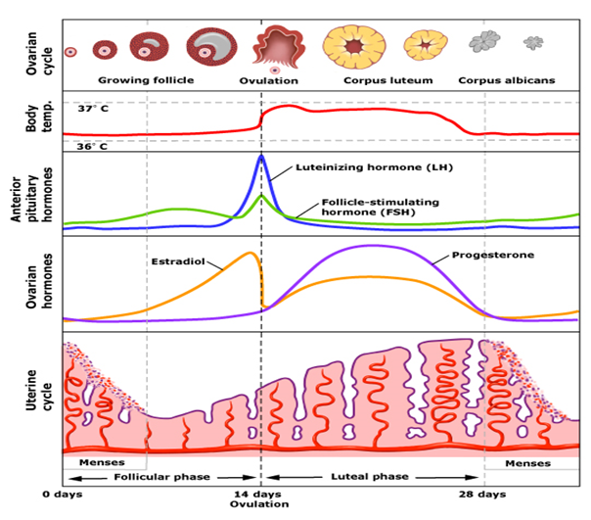

1. Follicular phase
   1. Begins with menstrual flow → decreased estrogen and progesterone → GnRH increases → FSH and LH increase → follicles start to produce more estrogen → regrow the endometrial lining
   2. More estrogen → **negative feedback** → GnRH, LH and FSH concentrations level off
2. Ovulation
   1. Late follicular phase: developing follicles secrete more estrogen → estrogen concentrations reaches a threshold that paradoxically results in **positive feedback** → GnRH, LH and FSH levels spike
   2. **LH surge** → induces ovulation → **release of the ovum** from the ovary into the abdominal (peritoneal) cavity
3. Luteal phase
   1. LH causes the ruptured follicle to form the **corpus luteum** → secretes progesterone → maintains the uterine lining for implantation
   2. High levels of progesterone → **negative feedback** on GnRH, FSH and LH → **prevents ovulation of multiple eggs**
4. Menstruation (**if implantation does not occur**)
   1. Corpus luteum loses its stimulations from LH → progesterone decreases → uterine lining sloughs off → no more block on GnRH → cycle repeats
5. Pregnancy (if fertilization occurs)
   1. **First trimester**: Zygote develops into blastocyst that will implant in the uterine lining → secretes human chorionic gonadotropin (**hCG**) i.e. **analog of LH** → can stimulate LH receptors and maintain corpus luteum → continues to secrete estrogen and progesterone
   2. **Second trimester**: hCG levels decline because **placenta** has grown to a sufficient size to secrete **progesterone and estrogen** by itself → high levels serve as negative feedback → prevent further GnRH secretion
6. Menopause
   1. Aging → follicles decrease → less estrogen → more GnRH and FSH → desensitise FSH on remaining follicles → ovarian atrophy
   2. Estrogen and progesterone levels drop → endometrium also atrophies → **menstruation stops**

Spermatogenesis vs Oogenesis

* All primary oocytes produced and arrested at Prophase I by birth
* One secondary oocyte (every menstrual cycle) arrested at Metaphase II
  + Completes Meiosis II if fertilization occurs
  + Sheds with the endometrial blood if no fertilization occurs

